**SYSTEMS MANUAL**

1. Minimum hardware and software requirements:
   1. Operating System:
      1. Generally any OS that can run visual studio
      2. Windows 7, Windows 8 or Windows 10
      3. Mac OSX 10.8, 10.9, 10.10 or 10.11
   2. Hardware:
      1. Generally any computer that can run visual studio
      2. Processor (CPU) with 2 gigahertz (GHz) frequency or above
      3. A minimum of 1 GB of RAM
      4. Monitor Resolution 1024 X 768 or higher
      5. A minimum of 10 MB of available space on the hard disk
      6. Keyboard
   3. Software:
      1. Visual Studio- Version 2015 to present
2. Installation Guide:
   1. Download the latest Community Version of Visual Studio at the following link:
      1. `https://visualstudio.microsoft.com/downloads/`

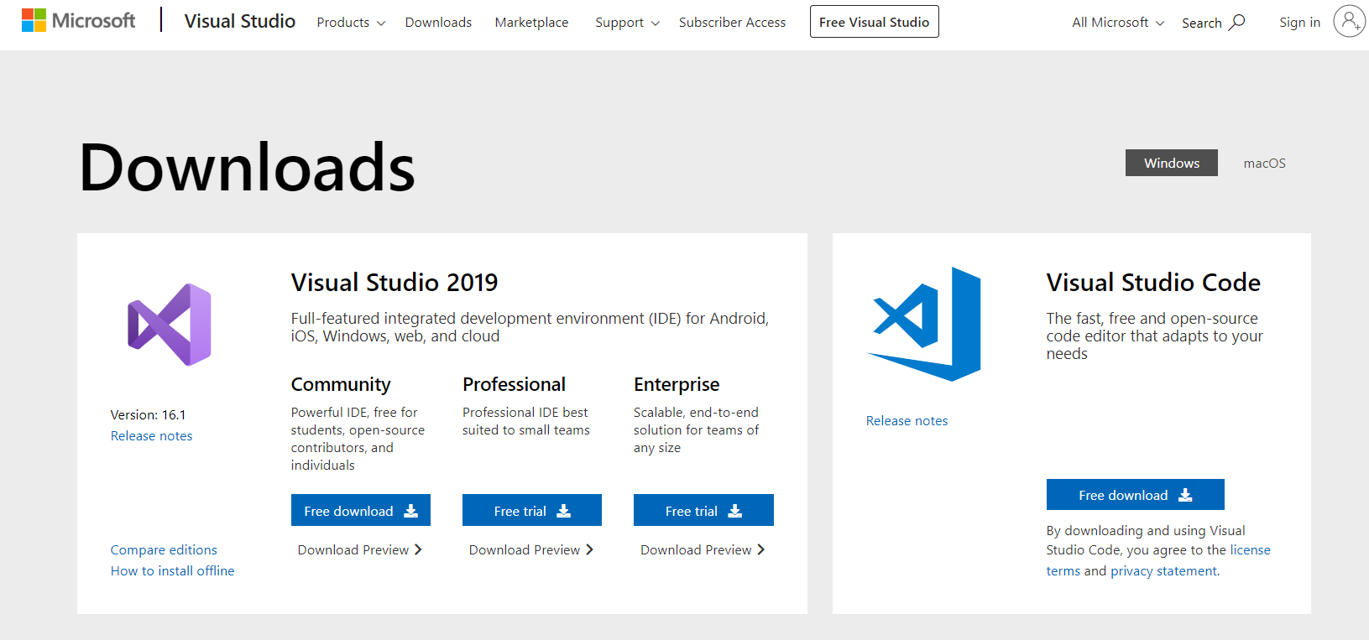

* + 1. Launch solution

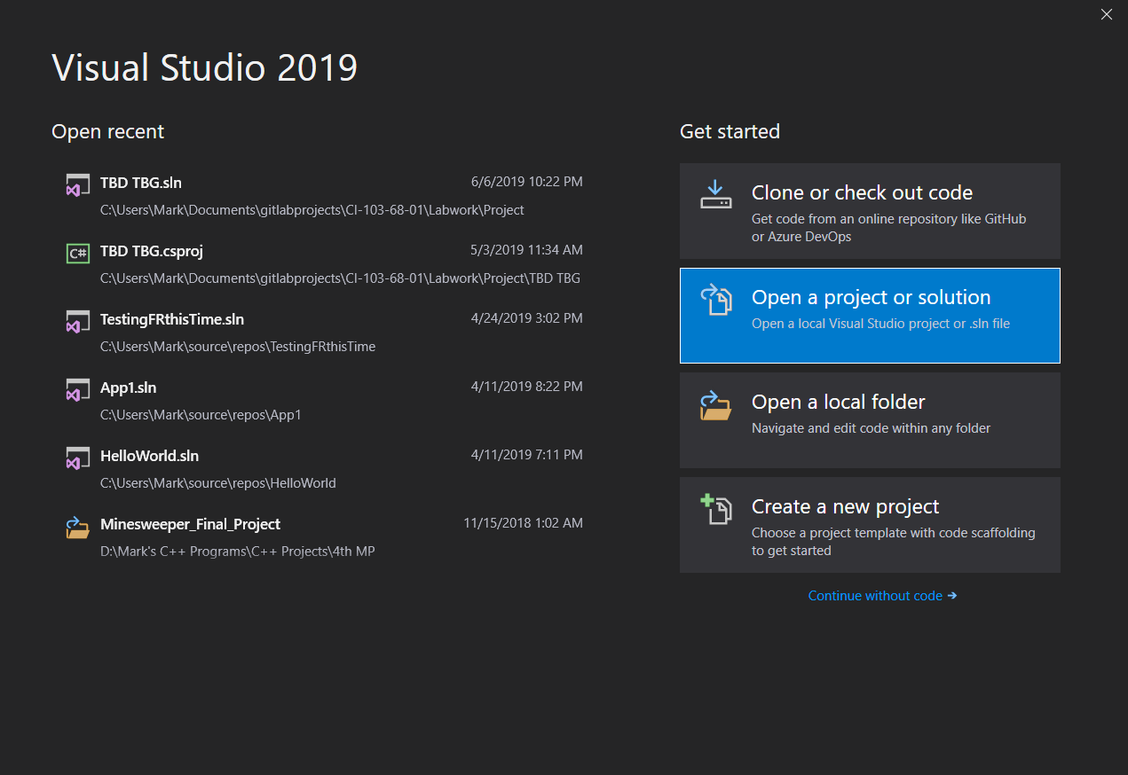

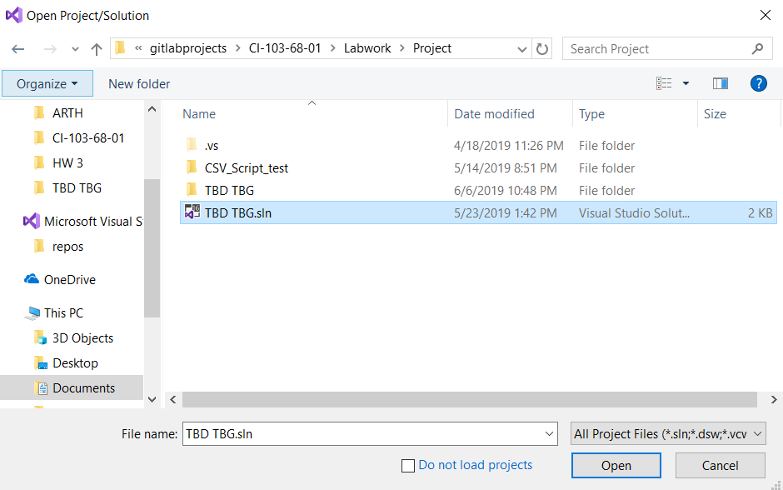

* + 1. Press the green button to run the game (or F5)

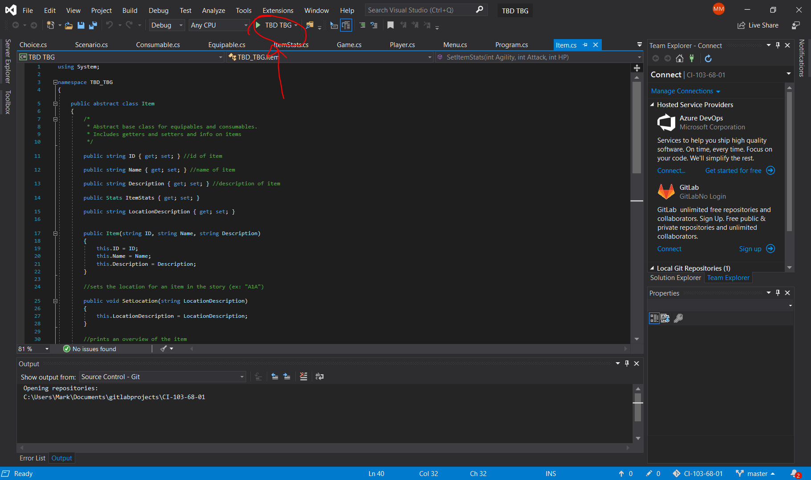

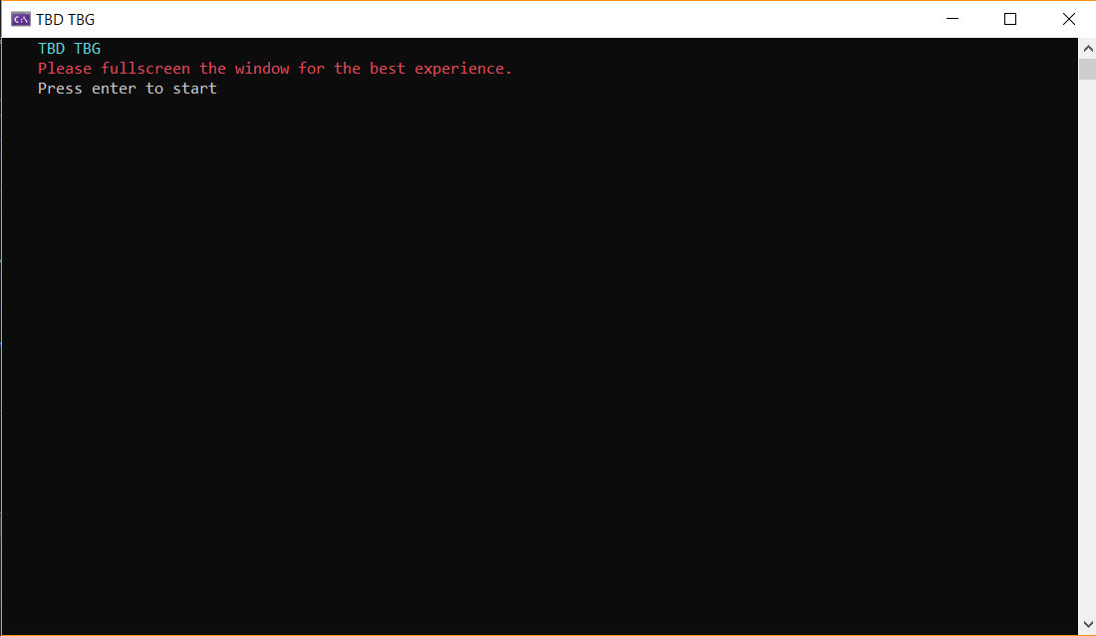

1. Errors:
   1. Not full screening:
      1. Not full screening the game in the beginning results in a broken title screen

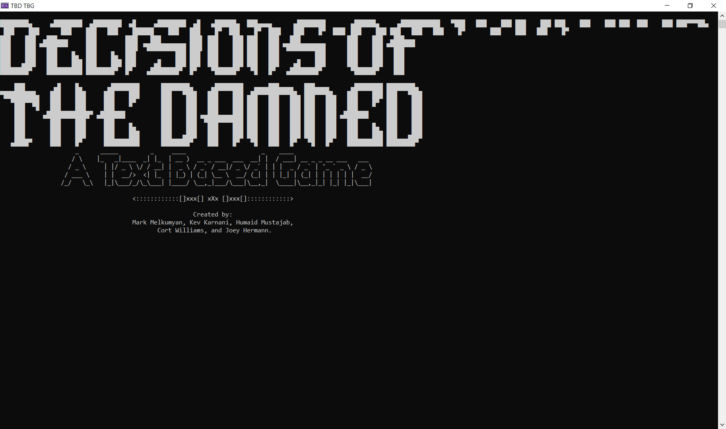

* 1. Bad input:
     1. If you type in an input that isn't a valid option (options are shown in blue)

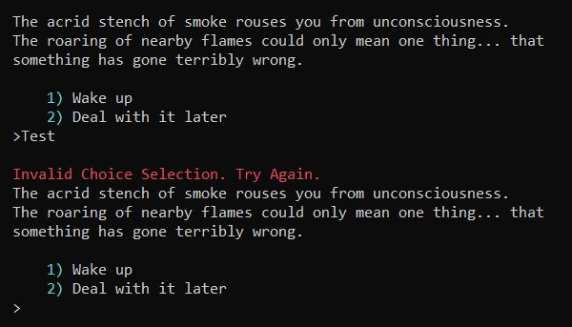

1. CONTACT:
   1. Phone - 123-456-7890
   2. Email - [mam962@drexel.edu](mailto:mam962@drexel.edu)